Paul Barlow

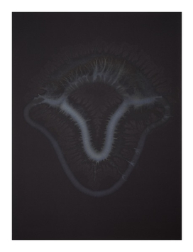 | Paul Barlow  OOO, 2022  Acrylic on canvas  140 x 105 cm | 55 x 41 1/4 in  (PAB 02)
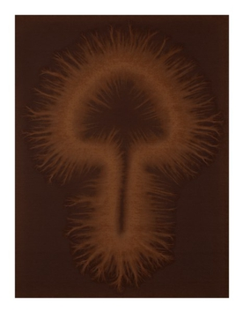 | Paul Barlow  0OO, 2022  Acrylic on canvas  140 x 105 cm | 55 x 41 1/4 in  (PAB 03)
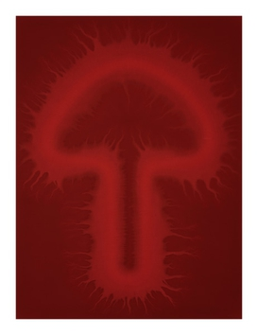 | Paul Barlow  OO0, 2022  Acrylic on canvas  140 x 105 cm | 55 x 41 1/4 in  (PAB 04)
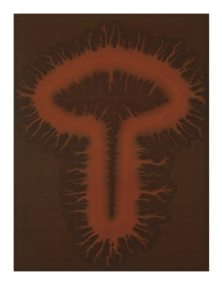 | Paul Barlow  O0O, 2022  Acrylic on canvas  140 x 105 cm | 55 x 41 1/4 in  (PAB 05)
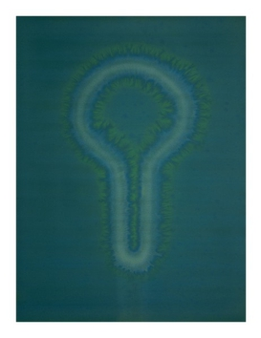 | Paul Barlow  ooo, 2022  Acrylic on canvas  105 x 140 cm | 41 1/4 x 55 in  (PAB 06)
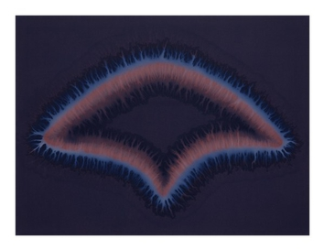 | Paul Barlow  oooo, 2022  Acrylic on canvas  105 x 140 cm | 41 1/4 x 55 in  (PAB 07)

